## BUSINESS PROCESS MANAGEMENT AND

## SYSTEMS

**ASSIGNMENT – 1a**

**Sayed Irfan (**00287698T)

**Mohammed Zhoeb (**00287693T)

**Abdul Hameed Khan Mohammed (**00290606T) **Facilitator –** ALEX DOMINGUEZ

|  |  |  |  |
| --- | --- | --- | --- |
|  | |  | | --- | |  | |  |

In the year 1982, Fasha Mahjoor decided to jump in the complex scientific field of sample separation and chromatography by founding one of the leading chromatography columns selling multi-national company known as **Phenomenex**. Phenomenex technologies have played a huge part in making the future of scientific analysis and investigation of different products which belong in market today. Phenomenex is known to be industry experts in dealing with surface chemistry, polymer particle and silica particle technology, columns for separation process, chemistry processes and equipment’s, etc. Phenomenex product range starts from extraction tubes which are used to clean the blood samples for clinical purposes, Chromatography columns used for testing the purity of samples and all the contents present in sample and Gas Chromatography columns which particularly help in testing of pesticides in food, etc. With the help of these chromatography columns, one can test from crude oil to plastics containers, from colour paints used to paint the house to shampoos and soap one use in daily to daily life. One of main uses involve testing of drugs and other pharmaceutical products in order to assure safety for everyone ("Phenomenex UHPLC, HPLC, SPE, GC - Leader in Analytical Chemistry Solutions", 2020).

Phenomenex has been following the norms of **Business Process Management (BPM) approach** as to have the agility required to withstand in current intense business environment where business have transformed themselves into giants through heaps on innovation and agility to work out and make necessary changes when the markets shifts intensely with time. Using the BPM approach also leads a business to achieve more value and discipline. Business process management can also be known as a methodology which promotes business mapping, analysis, evaluation and continuous improvement for the betterment of business. There are **3 pillars of BPM** which involves **people** involved in the business, **Processes** involved in the business and **technology**. Together these pillars make a business stand and certainly same works in the favour of Phenomenex. Phenomenex has also implemented **Enterprises Resources Planning (ERP) systems** which help them to store all the company business data, contacts, sales, revenues throughout years, etc. These data can be accessed by stakeholders and if needed by needed authority to consider proper business planning ahead. Phenomenex also implemented **Workflow Management Systems (WfMS)** that help them distribute works to different departments such as data integrity, sales, marketing, I.T, logistics which all together work to make the business work (van der Aalst, H. M. ter Hofstede & Weske, 2004).

Phenomenex has also used several components of BPM in order to lead the business sustainably. **Modelling and simulation** were done to understand the business at operational level. Starting from getting raw data/contacts to making those contacts buy columns through sales team, proper marketing at several events, Manufacturing of columns in California, USA, logistics approach for import and delivery of products. This gives better business insights and sort to improve business performance. **Business Activity Monitoring (BAM)** approach lead incorporation of **Key performance indicators (KPIs)** in the business. Performance was seen through monthly, quarterly and yearly revenues generated through sales. Every year new targets were set to be achieved. **Rules and Framework** was set in order to maintain discipline in work environment, standards to be maintained were set and working together was mandatory effort. **Collaboration between people** from different departments and background was a major criterion for business success. A standardized workflow, clearer rules and regulations to be followed, roles to be worked on were made clear in order to avoid any miscommunication for work to be efficient and effective.

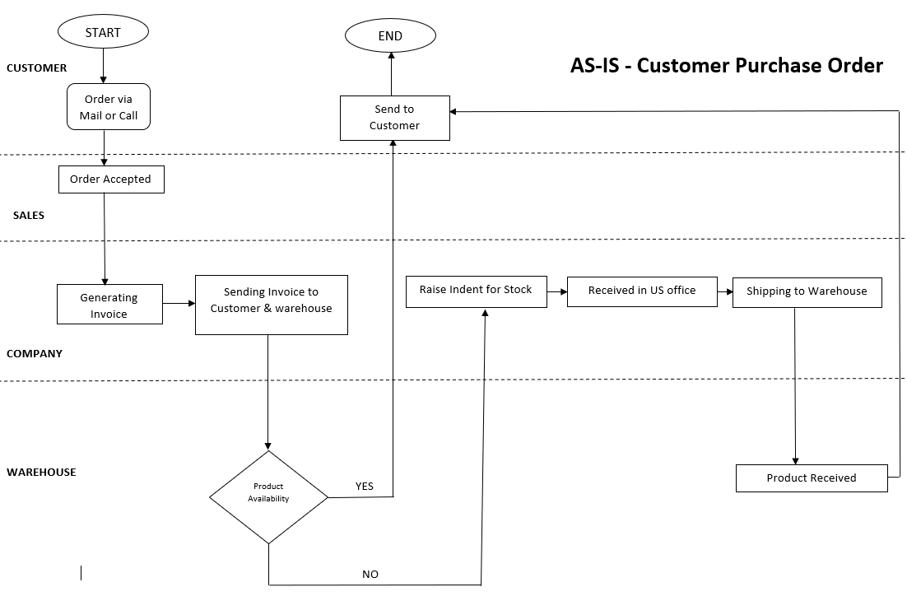

Above mentioned Swimlane diagram represents the current process of customer order purchase in Phenomenox Pvt Ltd. The process illustrates the complete information related to the customer order from the time it is raised for order till it is delivered to the customer. The entire process is categorized into 4 major sub sections which upholds the responsibility of the product during that particular phase respectively.

* CUSTOMER PHASE:

The process begins with a customer placing an order for a product via Mail or call. Then the order request is sent to sales department for the approval.

* SALES PHASE:

Sales department acknowledges the order request from the customer based on the acceptance criteria and the product availability. Post which purchase request is sent to the company for further processing.

* COMPANY PHASE:

Company back office receives the product request, including all the required parameters invoice for that particular product is raised. Generated invoice copy will be shipped to warehouse which provides the complete details of the purchase.

* WAREHOUSE:

Based on the invoice received the product availability is detected in the warehouse under all measures.

* And if the product is available then it is directly shipped to the customer with the customer invoice copy.
* And if the product is not available then an indent is raised with the company member with complete details of the product.
* Post which the product details are sent for a purchase request to US office and purchased and shipped to the ware house.
* And once the new product is received in the warehouse, then the product is delivered to the Customer directly.

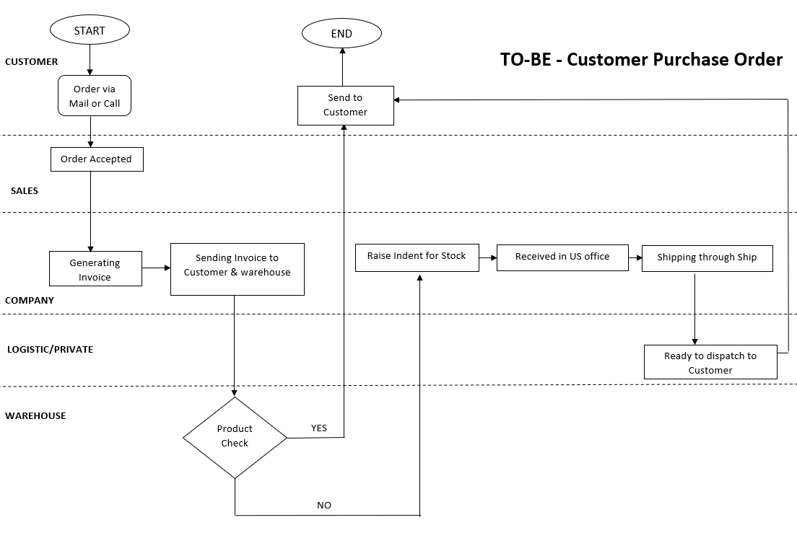

Above mentioned Swimlane diagram represents the proposed process of customer order purchase in Phenomenox Pvt Ltd. The new process illustrates the complete information related to the customer order from the time it is raised for order till it is delivered to the customer. The entire process is categorized into 5 major sub sections which uploads the responsibility of the product during that particular phase respectively.

* CUSTOMER PHASE:

As mentioned above

* SALES PHASE:

As mentioned above

* COMPANY PHASE:

As mentioned above

* WAREHOUSE:

Based on the invoice received the product availability is detected in the warehouse under all measures.

* And if the product is available then it is directly shipped to the customer with the customer invoice copy.
* And if the product is not available then an indent is raised with the company member with complete details of the product.
* Post which the product details are sent for a purchase request to US office and purchased and shipped to the Logistics department.
* LOGISTIC/PRIVATE:

This is the new phase included in the proposed order purchase process, where the newly ordered stock from the company will not be sent to the warehouse instead it will be sent to the logistic department which will receive the product based on the invoice.

These department is included to avoid the delay of the product (column) to the customers. As columns are important for various purposes and it has to be replaced at a regular interval of time, any delay in delivery process might cause delay in the operation process.

**Critical analysis on two mappings**

* The good part of introducing the Private logistics is that the product quality wouldn’t be compromised and the delivery to the customer would be at the very earliest convenience.
* Tracking of the shipment would be also much easier for the buyers.
* The cost of damage to the product while shipment is high and will be again covered by the private logistics and company won’t be at fault.
* Private logistics will be having several warehouses in different locations all across the nation and worldwide. Hence, easier to store and deliver the product to the consumer. As Phenomenex had only 1 warehouse, it was a quick delivery to near by location but all other inter-state locations far from warehouse were hard to reach and deliver.

**COST AND BENEFITS ANALYSIS**

1. To prevent the damage due to lack of proper delivery timing, hiring a private logistics need more investment into logistics than before.
2. An average product of Phenomenex comes with about 30% of profit to the table and about 2.5% of that 30% profit is put into traditional logistics systems.
3. Whereas hiring a private logistics accounts adds an extra 2.5%. It cost 5% out of 30% of total profits to ensure faster delivery to the consumer.
4. The benefits include efficiency of the system and it also ensure that the compliances and policies are being followed.
5. It improves business agility and gives complete visibility of the whole process which makes it easier and secure and also increases the opportunities for improvement and to raise the profit margin. The mobility of the product is smooth and consistent which makes this process more beneficial.
6. It also benefits the organization to overcome the changes in the market and remain consistent and helps to maintain sustainability of the company and also it gives better experiences in collaboration and this also boosts the customer satisfaction.
7. According to the research done by Matthew C. H. Yeung and co-workers, there is a linear relationship between customer satisfaction and profitability (Yeung, Ging & Ennew, 2002).
8. Giving a better consumer experience also lead to building exceptional customer loyalty which indeed gain more trust. On such basis with higher demand will give more profit to the company despite spending 5% of profit on private logistics.

**Advantages**

1. The advantages of the implementation of private logistics will lead to better flow of the goods and the distribution to the consumer will be hassle free.
2. Implementation of private logistics will be easy and won’t affect other processes.
3. Private logistics will be covering insurance for product damage and security. Also, they will be engaging all their warehouses around the nation and worldwide for securing products and easy delivery (Yeung, Ging & Ennew, 2002).
4. This process helps in assuring that everyone who is part of this process have their guidelines set up on how to perform their task.
5. This process makes it easier to look for cost and time saving opportunities.
6. This process helps in analyze the current situation and provides opportunities to improve or to make any changes to help to boost the productivity of the organization.

**Disadvantages**

1. Loss of initial funds during the implementation stage of a private logistics will come as the major drawback for the organization. But will be advantage in the long run.
2. The other alarming side effects include consumer abuse and lack of adequate administrative supervision.
3. This process would not help during the rapid changes in the market as it won’t be able the cope up with the innovations.
4. The quality of the product cannot be checked / verified by the logistics before sending it to the customers.

Through this approach the agility of the current business environment is maintained and necessary changes and innovations are made when the market shits with time. It also helps in analysing and evaluation of the productivity process for the betterment of the business.

**REFERENCES:**

Phenomenex UHPLC, HPLC, SPE, GC - Leader in Analytical Chemistry Solutions. (2020). Retrieved 19 March 2020, from <https://www.phenomenex.com/>

Shan, L., Zhang, Z., & Wang, X. (2011). Integration of Logistics Resources Based on Logistics Network. *Contemporary Logistics*, 51-56. doi: 10.5503/j.cl.2011.03.009

van der Aalst, W., H. M. ter Hofstede, A., & Weske, M. (2004). Business process management: a survey. *Business Process Management Journal*, *10*(2), 1-12. doi: 10.1108/bpmj.2004.15710baa.001

Yeung, M., Ging, L., & Ennew, C. (2002). Customer satisfaction and profitability: A reappraisal of the nature of the relationship. *Journal Of Targeting, Measurement And Analysis For Marketing*, *11*(1), 24-33. doi: 10.1057/palgrave.jt.5740064